Interactive Map

Project Setup:
1. Navigate to - https://github.com/Ayeshaq09/Unified-mentor-projects You will see all 8 projects.
2. To get the projects onto your system: click on "Code" button and copy the link - https://github.com/Ayeshaq09/Unified-mentor-projects.git
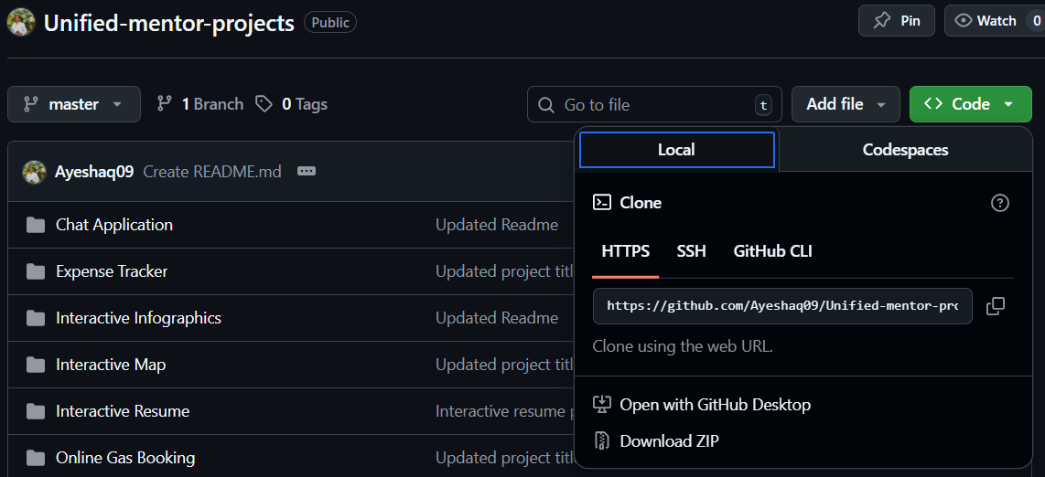
3. Open git bash and run the following command:
git clone https://github.com/Ayeshaq09/Unified-mentor-projects.git
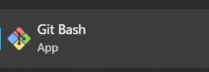
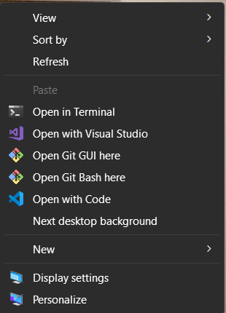
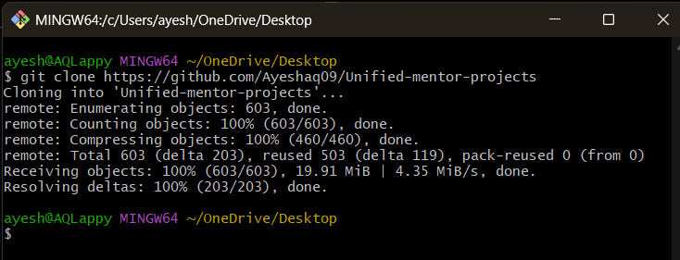
4. Once cloning is done, you get all the 8 projects onto your system.

About the project:
This project displays an openstreet map and allows the user to search for various locations.

Features
- Interactive Map, search functionality, filter the results as per the selected category.
- Mobile-responsive, clean design.

Technologies Used
- HTML5, CSS3, JavaScript, React
- leaflet.js and OpenStreet map
- JSON dataset

Interactive Map project setup:
1.Open the folder in vscode and in terminal run – npm install
This command will install all the dependencies in the frontend required for the project to run.
Then run – npm start
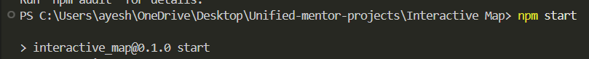

Functionality of the application:
- The project displays an openstreet map with 6 famous locations in India.
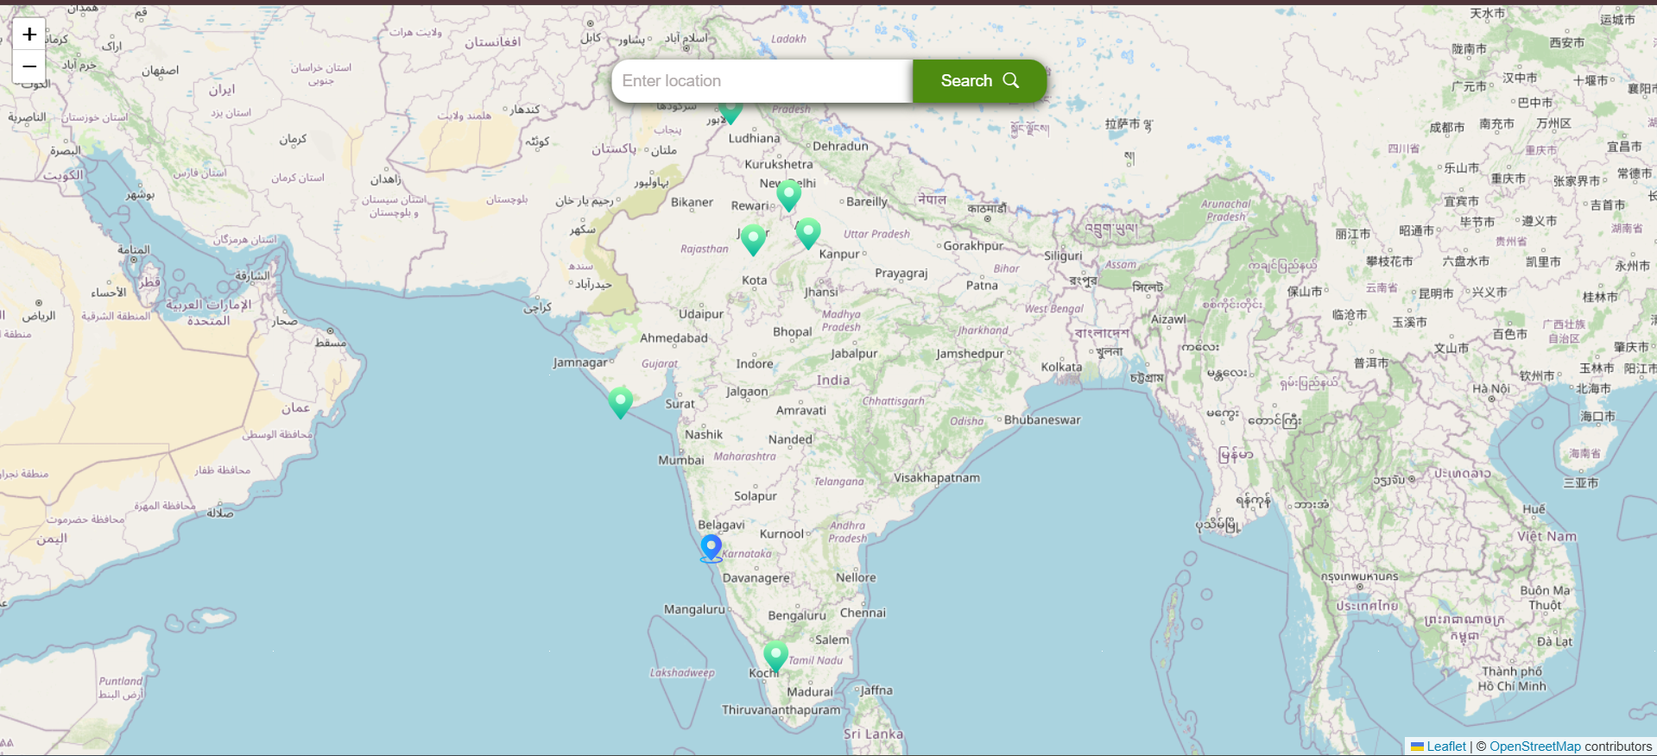

- Click on the green icon/point to see the popup that contains image, description and address of the location.
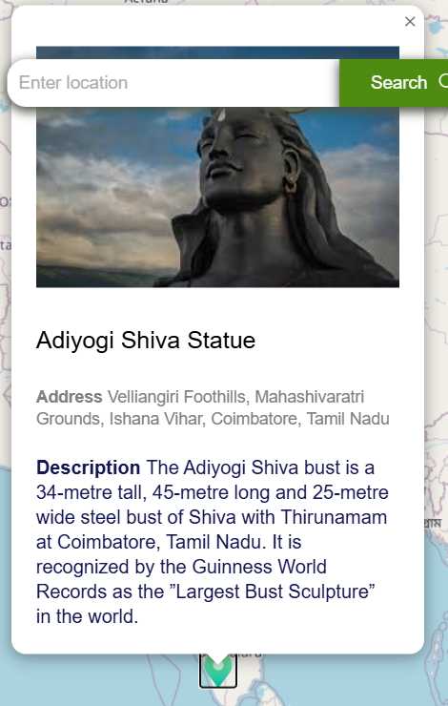

- The map also has a blue icon to display the current location of the user.
For this functionality to work, allow the application to use the current location.

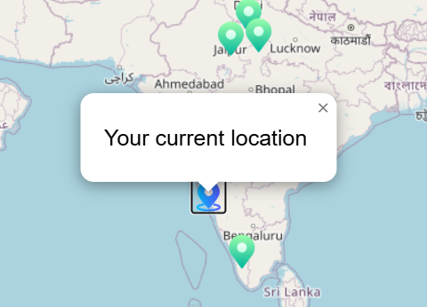

- User can search for various locations using search box. It will display the results below along with the categories at top.
You can filter results as per the categories.
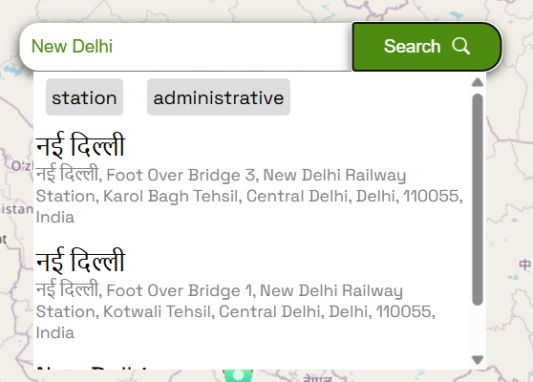
Filters
- Click on any result to navigate to that location and it also displays the corresponding icon.
eg: 'coffee icon' for cafes, 'temple icon' for holy places and so on.
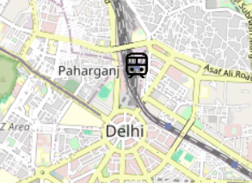

- Click on the searched result to display a popup that contains name and address of the location.
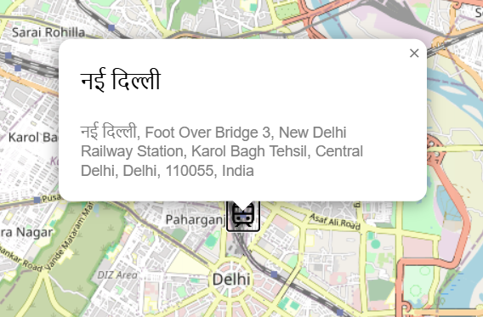

- Resize the screen to check the responsiveness of the application.
**Note**: openstreet map doesn't work on mobile screens i.e if you go to mobile screen size in inspect mode and try to search for a location, it displays an error so to check the responsiveness just resize the browser window instead of using developer tools in inspect mode.

